De Rust Futura Academy, Grabouw

The University of Stellenbosch in partnership with ASNAPP assisted De Rust Futura Academic School with the turnaround strategy for their tunnel farming operation. The school requested the University to assist with integrating the tunnel farming operation as part of their curriculum.

ASNAPP started in May 2017 with a site assessment of what is needed to optimize the existing tunnel infrastructure. The University of Stellenbosch contribute financially to improve the infrastructure and also provide input cost for the growing of beans. ASNAPP started with mentorship with the permanent workers, teachers and leaners at the school. We also did minor adjustments to the infrastructure to maximize the production potential of the crop.

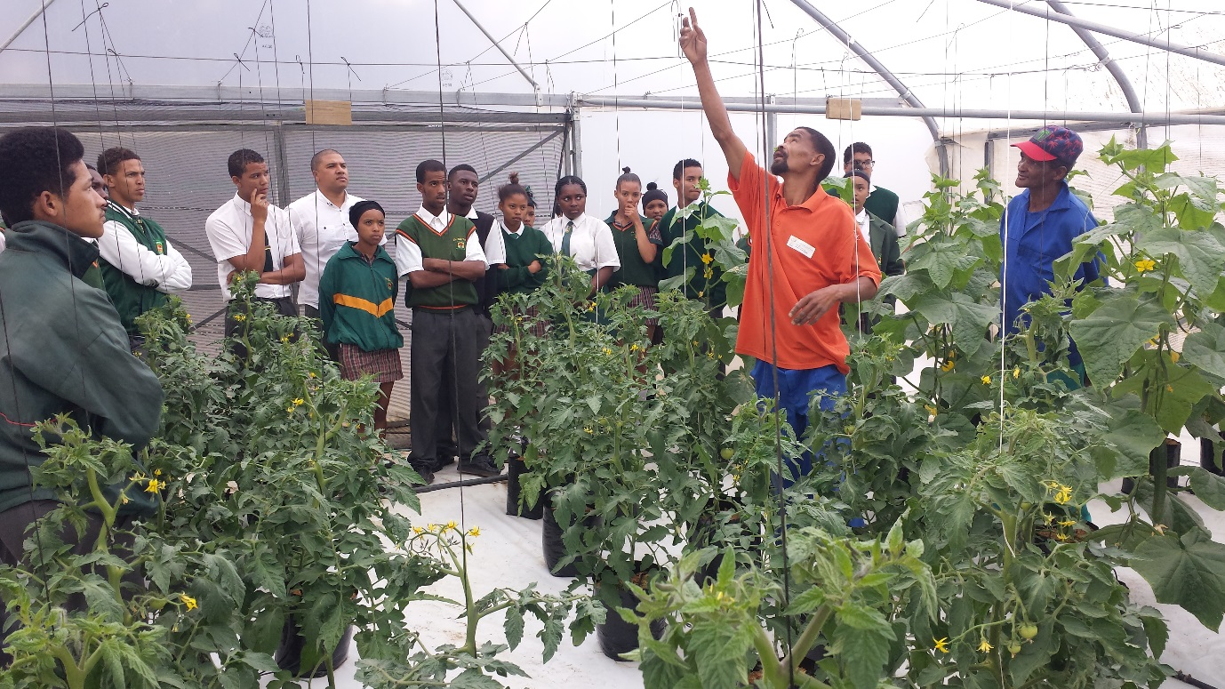
De Rust Futura Academy School(Grabouw)

